NoteCatcher
 | Data | Where to Access | Possible Uses
Class Report
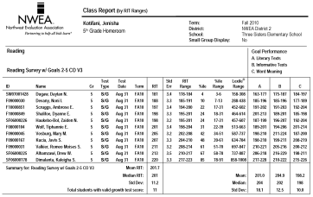
Class Breakdown Reports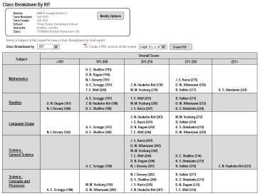
DesCartes or Primary Grades Instructional Data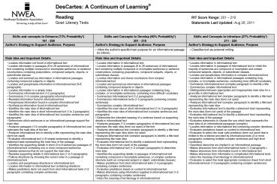
Student Progress Report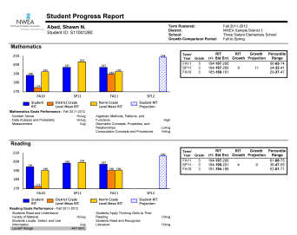
Primary Grades Skills Checklist or Screening Class & Student Report