Essential Reports Chart
 | Where to Access | Key Ideas and Possible Uses
Teacher/Class Report
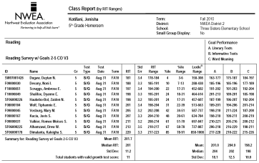
Class Breakdown Reports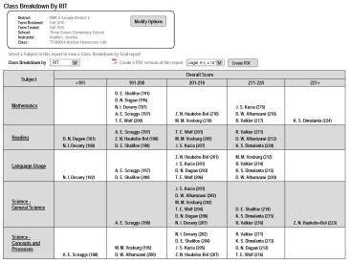
Achievement Status and Growth Reports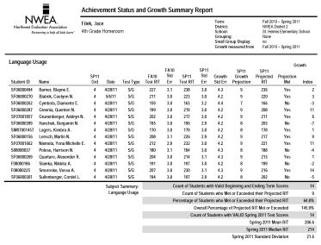
Student Goal Setting Worksheet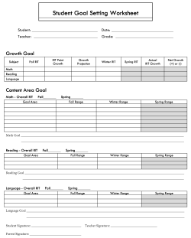
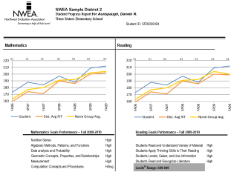
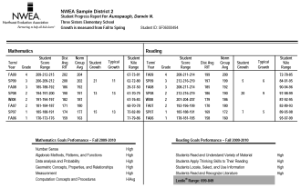
Student Progress Report

